Application of Laplace transformation
The Laplace transformation is useful in solving differential equations. There are four steps to follow, such as
Differential equation

Apply Laplace Transformation

Use the Initial Values

Solve the algebraic equation for

Apply Inverse Laplace Transformation.

Important formulae
$$L\left\{\dot{f}(t)\right\}=L\left\{\frac{df\left(t\right)}{dt}\right\}= sF\left(s\right)-f\left(0\right).$$
$L\left\{\ddot{f}\left(t\right)\right\}=L\left\{\frac{d^{2}f(t)}{dt^{2}}\right\}= s^{2}F\left(s\right)-sf\left(0\right)-\dot{f}(0)$ where $f\left(0\right),$ and $\dot{f}(0)$are the initial values of $f$ and$\dot{f}$.
$$L\left\{\overset{⃛}{f}\left(t\right)\right\}=L\left\{\frac{d^{3}f(t)}{dt^{3}}\right\}= s^{3}F\left(s\right)-s^{2}f\left(0\right)-s\dot{f}\left(0\right)-\ddot{f}\left(0\right).$$
The general case for the Laplace transform of an $n$^{th} derivative is
$$L\left\{f^{n}\left(t\right)\right\}=L\left\{\frac{d^{n}f(t)}{dt^{n}}\right\}= s^{n}F\left(s\right)-s^{n-1}f\left(0\right)-s^{n-2}f^{'}\left(0\right)-…-f^{\left(n-1\right)}\left(0\right).$$
Solving Ordinary Differential equations with constant coefficients:
The Laplace transform is useful in solving linear ordinary differential equations with constant coefficients. Having obtained expressions for the Laplace transforms of derivatives, we are now in a position to use Laplace transform and also inverse Laplace transform methods to solve ordinary differential equations with constant coefficients. To illustrate this, consider the general second-order differential equation
$\frac{d^{2}y}{dt^{2}}+α\frac{dy}{dt}+βy=f(t)$ or $\ddot{y}(t)+α\dot{y\left(t\right)}+βy(t)=f(t)$ (1)
Where, $∝$ and $β$ are constants, subject to initial conditions
$y\left(0\right)=A, \dot{y}\left(0\right)=B$ (2)
where A and B are given constants. On taking the Laplace transform of both sides and using condition (2), we obtain the algebraic equation for determination of$L\left\{y\left(t\right)\right\}=Y(s)$. The required solution is then obtained by finding the inverse Laplace transform of$Y(s)$. The method is easily extended for the higher order differential equations.
Example:
Solve the differential equation or the initial value problem
$$\ddot{y}(t)+y(t)=e^{t}, y\left(0\right)=1, \dot{y}\left(0\right)=-2.$$
Solution:
Given,
$\ddot{y}(t)+y(t)=e^{t},$
$⇒ L\{\ddot{y}(t)\}+L\{y(t)\}=L\{e^{t}\}$ [applying Laplace transformation]
$⇒$ $s^{2}Y(s)-sy\left(0\right)-\dot{y}(0)+Y(s)=\frac{1}{ s-1}$ [let, $L\left\{y\left(t\right)\right\}=Y(s)]$
$⇒s^{2}Y(s)-s\left(1\right)-\left(-2\right)+Y(s)=\frac{1}{ s-1}$ [using the initial values]
$⇒$ $Y(s)=\frac{s^{2}-3s+3}{(s^{2}+1) \left(s-1\right)}$ [solving the equation]
$⇒L^{-1}\left\{Y\left(s\right)\right\}=L^{-1}\left\{\frac{A}{ s-1}+\frac{Bs+C}{s^{2}+1}\right\}$ [applying inverse Laplace transformation and using partial fraction]
$$\frac{s^{2}-3s+3}{(s^{2}+1) \left(s-1\right)}≡\frac{A}{ s-1}+\frac{Bs+C}{s^{2}+1}$$
$$⇒s^{2}-3s+3≡A\left(s^{2}+1\right)+\left(Bs+C\right)\left(s-1\right)$$
$$⇒s^{2}-3s+3≡\left(A+B\right)s^{2}+\left(C-B\right)s+A-C$$
Equating coefficients
$$A+B=1$$
$$C-B=-3$$
$$A-C=3$$

Solving we get,$A=\frac{1}{2},$ $B=\frac{1}{2}$, $C=-\frac{5}{2}$
$$⇒L^{-1}\left\{Y\left(s\right)\right\}=L^{-1}\left\{\frac{\frac{1}{2}}{ s-1}+\frac{\frac{s}{2}}{s^{2}+1}-\frac{\frac{5}{2}}{s^{2}+1}\right\}$$

$⇒y(t)=\frac{e^{t}}{2}+\frac{1}{2}cost-\frac{5}{2}sint$.

Therefore the solution of the differential equation is$y(t)=\frac{e^{t}}{2}+\frac{1}{2}cost-\frac{5}{2}sint$.
Example: A resistance R in series with inductance L is connected with e.m.f $E(t) =t.$ The current $i(t)$ is given by
$$L\frac{di}{dt}+Ri=t; i\left(0\right)=0$$
Use Laplace transform to find the current $i(t).$
Solution:
Given,
$$L\frac{di}{dt}+Ri=t$$
$⇒LL\left\{\frac{di}{dt}\right\}+RL\left\{i\right\}=L\left\{t\right\}$ [applying Laplace transformation]
$⇒$ $LsI\left(s\right)-L.i\left(0\right)+RI(s)=\frac{1}{ s^{2}}$ [let, $L\left\{i\left(t\right)\right\}=I(s)]$
$⇒$ $LsI\left(s\right)-L(0)+RI(s)=\frac{1}{ s^{2}}$ [using the initial values]
$⇒I\left(s\right)=\frac{1}{\left(Ls+R\right)s^{2}}$ [Solving the equation]
$⇒ L^{-1}\left\{I\left(s\right)\right\}=L^{-1}\left\{\frac{1}{\left(Ls+R\right)s^{2}}\right\}$ [applying inverse Laplace transformation]
$⇒$ $i\left(t\right)=L^{-1}\left\{\frac{A}{s}+\frac{B}{s^{2}}+\frac{C}{\left(Ls+R\right)}\right\}$[ using partial fraction]
$$\frac{1}{(Ls+R)s^{2}}≡\frac{A}{s}+\frac{B}{s^{2}}+\frac{C}{(Ls+R)}$$
$$⇒1≡As(Ls+R)+B(Ls+R)+Cs^{2}$$
$$⇒1≡(LA+C)s^{2}+(AR+BL)s+BR$$
Equating coefficients
$$LA+C=0$$
$$AR+BL=0$$
$$BR=1$$
Solving we get,$A=-\frac{L}{R^{2}}$, $B=\frac{1}{R}$, $C=\frac{L^{2}}{R^{2}}$
Hence,
$i\left(t\right)=L^{-1}\left\{-\frac{L}{R^{2}}\frac{1}{s}+\frac{1}{R}\frac{1}{s^{2}}+\frac{L^{2}}{R^{2}}\frac{1}{\left(Ls+R\right)}\right\}$
$$⇒i\left(t\right)=L^{-1}\left\{-\frac{L}{R^{2}}\frac{1}{s}+\frac{1}{R}\frac{1}{s^{2}}+\frac{L^{2}}{R^{2}L}\frac{1}{\left(s+\frac{R}{L}\right)}\right\}$$
$$⇒i\left(t\right)=-\frac{L}{R^{2}}L^{-1}\left\{\frac{1}{s}\right\}+\frac{1}{R}L^{-1}\left\{\frac{1}{s^{2}}\right\}+\frac{L}{R^{2}}L^{-1}\left\{\frac{1}{\left(s+\frac{R}{L}\right)}\right\}$$
$⇒i\left(t\right)=-\frac{L}{R^{2}}+\frac{t}{R}+\frac{L}{R^{2}}e^{-\frac{R}{L}t}$.

Example:
An inductor of 2 henrys, a resistor of 16 ohms and a capacitor of .02 farads are connected in series with an e.m.f. of E volts. At $t=0$the charge on the capacitor and current in the circuit are zero. Find the charge and current at any time $t>0$ if E$=300$ (volts).
Let $q(t)$ and $i(t)$ be the instantaneous charge and current respectively at time t. By Kirchhoff’s law’s, we have
$$2\frac{di}{dt}+16i+\frac{q}{0.02}=E$$
$⇒2\frac{d^{2}q}{dt^{2}}+16\frac{dq}{dt}+50q=E$ [since$i=\frac{dq}{dt}$]
$⇒2\frac{d^{2}q}{dt^{2}}+16\frac{dq}{dt}+50q=E$…… (1)
With the initial conditions
$$q\left(0\right)=0, i\left(0\right)=\dot{q}\left(0\right)=0.$$
Solution:
If$E=300$, then equation (1) becomes
$$\frac{d^{2}q}{dt^{2}}+8\frac{dq}{dt}+25q=150$$
$⇒L\left\{ \frac{d^{2}q}{dt^{2}}\right\}+8L\left\{\frac{dq}{dt}\right\}+25L\left\{q\right\}=L\left\{150\right\}$ [applying Laplace transform]
$⇒\left\{s^{2}Q(s)-s q\left(0\right)-\dot{q}\left(0\right)\right\}+8\left\{sQ(s)-q\left(0\right)\right\}+25Q(s)=\frac{150}{s}$ [let, $L\left\{q\left(t\right)\right\}=Q(s)]$
$⇒\left\{s^{2}Q(s)-s .0-0\right\}+8\left\{sQ(s)-0\right\}+25Q(s)=\frac{150}{s}$ [using the initial values]
$$⇒s^{2}Q(s)+8sQ(s)+25Q(s)=\frac{150}{s}$$
$${⇒(s}^{2}+8s+25)Q=\frac{150}{s}$$
$⇒Q(s)=\frac{150}{s{(s}^{2}+8s+25)}$ [ solving the equation]
$$⇒ L^{-1}\left\{Q\left(s\right)\right\}=L^{-1}\left\{\frac{150}{s(s^{2}+8s+25)}\right\}$$
$⇒ q(t)=L^{-1}\left\{\frac{A}{s}+\frac{Bs+C}{(s^{2}+8s+25)}\right\}$ [ using partial fraction]
$$\frac{150}{s(s^{2}+8s+25)}≡\frac{A}{s}+\frac{Bs+C}{(s^{2}+8s+25)}$$
$$⇒150≡A(s^{2}+8s+25)+(Bs+C)s$$
$$⇒150≡(A+B)s^{2}+(8A+C)s+25A$$
Equating coefficients
$$A+B=0$$
$$8A+C=0$$
$$25A=150$$
Solving we get,$A=6$, $B=-6$, $C=-48$
$$q(t)=L^{-1}\left\{\frac{6}{s}-\frac{6s+48}{(s^{2}+8s+25)}\right\}$$
$$⇒q(t)=L^{-1}\left\{\frac{6}{s}-\frac{6\left(s+4\right)+24}{{(s+4)}^{2}+9}\right\}$$
$$⇒q(t)=L^{-1}\left\{\frac{6}{s}\right\}-L^{-1}\left\{\frac{6\left(s+4\right)}{{(s+4)}^{2}+9}\right\}-L^{-1}\left\{\frac{24}{{(s+4)}^{2}+9}\right\}$$
$q(t)=6-6e^{-4t}Cos t-8 e^{-4t}\sin{3t}$ [applying inverse Laplace transformation]
$i(t)=\frac{dq}{dt}=50 e^{-4t}\sin{3t}$.

Example:
The current $i\left(t\right)$ in an electrical circuit is given by the DE, $\frac{d^{2}i}{dt^{2}}+2\frac{di}{dt}=\left\{\begin{aligned}0 , 0<t<10 \\ 1, 10<t<20 \\ 0, t>20\end{aligned}\right.$
$i\left(0\right)=\frac{di}{dt}\left(0\right)=0.$ Determine current $i(t).$
Solution: Using unit step function the DE becomes,
$\frac{d^{2}i}{dt^{2}}+2\frac{di}{dt}=u\left(t-10\right)-u\left(t-20\right)$ $……..(1).$
$⇒L\left\{\frac{d^{2}i}{dt^{2}}\right\}+2L\left\{\frac{di}{dt}\right\}=L\left\{u\left(t-10\right)\right\}-L\left\{u\left(t-20\right)\right\}$ [applying Laplace transform]
$⇒\left\{s^{2}I\left(s\right)-si\left(0\right)-\frac{di}{dt}\left(0\right)\right\}+2\left\{sI\left(s\right)-i(0)\right\}=$ $\frac{e^{-10s}}{s}-\frac{e^{-20s}}{s}$
[$∵L\{f(t).u\left(t-a\right)\}=e^{-as}L\{f(t+a)\}$
$⇒I\left(s\right)\left(s\left(s+2\right)\right)=$ $\frac{e^{-10s}}{s}-\frac{e^{-20s}}{s}$
$⇒I\left(s\right)=$ $\frac{1}{s\left(s+2\right)}\left(\frac{e^{-10s}}{s}-\frac{e^{-20s}}{s}\right)$
Applying inverse Laplace transform, we get
$$L^{-1}\left\{I\left(s\right)\right\}=L^{-1}\left\{\frac{1}{s\left(s+2\right)}\left(\frac{e^{-10s}}{s}-\frac{e^{-20s}}{s}\right)\right\}…………\left(2\right).$$
We know $L^{-1}\left\{e^{-as}G\left(s\right)\right\}=u\left(t-a\right).g\left(t-a\right)$ and $L^{-1}\left\{\frac{1}{s^{2}\left(s+2\right)}\right\}=\frac{t}{2}+\frac{e^{-2t}}{4}-\frac{1}{4}$.
$$∴i\left(t\right)=\left[\frac{\left(t-10\right)}{2}+\frac{e^{-2\left(t-10\right)}}{4}-\frac{1}{4}\right]u\left(t-10\right)-\left[\frac{\left(t-20\right)}{2}+\frac{e^{-2\left(t-20\right)}}{4}-\frac{1}{4}\right]u\left(t-20\right).$$
$$=\left\{\begin{aligned}0, 0<t<10 \\ \frac{\left(t-10\right)}{2}+\frac{e^{-2\left(t-10\right)}}{4}-\frac{1}{4}, 10<t<20 . \\ 5+\frac{e^{-2\left(t-10\right)}}{4}-\frac{e^{-2\left(t-20\right)}}{4}, t>20\end{aligned}\right.$$
Problem set 3.1
Apply Laplace transform to solve the following ordinary differential equations and hence justify your answer, where $\dot{y}≡\frac{dy(t)}{dt}$ and $\ddot{y}≡\frac{d^{2}y(t)}{dt^{2}}$ : (1-12)
1. $\dot{y}\left(t\right)=3;$ $y\left(0\right)=2.$ Ans: $y\left(t\right)=3t+2.$
2. $\dot{y}\left(t\right)=4t;$ $y\left(0\right)=1.$ Ans: $y\left(t\right)=2 t^{2}+1.$
3. $\dot{y}\left(t\right)=2t-1;$ $y\left(0\right)=3.$ Ans: $y\left(t\right)=t \left(t-1\right)+3.$
4. $\dot{y}\left(t\right)=t^{2};$ $y\left(0\right)=4.$ Ans: $y\left(t\right)= \frac{t^{3}}{3}+4.$
5. $\dot{y}\left(t\right)=e^{2t};$ $y\left(0\right)=2.$ Ans: $y\left(t\right)= \frac{e^{2t}}{2}+ \frac{3}{2}.$
6. $\dot{y}\left(t\right)+y\left(t\right)=2 ;$ $y\left(0\right)=0.$ Ans: $y\left(t\right)=2-2 e^{-t}.$
7. $\ddot{y}\left(t\right)=5 ;$ $y\left(0\right)=1,$ $\dot{y}\left(0\right)=2.$ Ans: $y\left(t\right)=\frac{t \left(5t+4\right)}{2} +1.$
8. $\ddot{y}\left(t\right)- 2 \dot{y}\left(t\right)=\cos{t ;}$ $y\left(0\right)=0,$ $\dot{y}\left(0\right)=1.$
Ans: $f\left(t\right)= \frac{7}{10} e^{2t}- \frac{4}{5} \left(\sin{t+\frac{1}{2}\cos{t}}\right)- \frac{1}{2}.$
9. $\ddot{y}\left(t\right)+3 \dot{y}\left(t\right)-y\left(t\right)=e^{t};$ $y\left(0\right)=\dot{y}\left(0\right)=0.$
Ans:
$f\left(t\right)=\frac{1}{3} e^{t}- \frac{1}{3} e^{\frac{-3t}{2}} \left[\cosh\left(\frac{\sqrt{13}}{2} t\right)+ \frac{5}{\sqrt{13}}\sinh\left(\frac{\sqrt{13}}{2} t\right)\right].$
10. $\ddot{y}\left(t\right)- 7\dot{y}\left(t\right)+12y\left(t\right)= 0, y\left(0\right)= 2, \dot{y}\left(0\right)=1.$
Ans: $y\left(t\right)=-5e^{4t}+7e^{3t}.$
11. $\ddot{y}(t) + y(t) =\left\{\begin{aligned}t, 0<t<1 \\ 0, t>1\end{aligned}\right.$ $,$ $y\left(0\right)= 0, \dot{y}(0)= 0.$
Ans: $y\left(t\right)=t-\sin{t}$ if $0<t<1$ and $\cos\left(t-1\right)+\sin\left(t-1\right)-\sin{t}$ if $t>1$.
Shifted data problems:
This is a short name for initial value problem with initial conditions referring to some later instant $t=t_{0}$ instead of $t=0.$ In this case, the conditions $y\left(0\right)$ and $y^{'}\left(0\right)$ occurring in the Laplace transform approach cannot be used immediately.

12. $y^{''}+y=2t,$ $y\left(\frac{π}{4}\right)=\frac{π}{2}, y^{'}\left(\frac{π}{4}\right)=2-\sqrt{2} .$
Solution: set $t=\overline{t}+ \frac{π}{4}$ so that $t=\frac{π}{4}$ gives $\overline{t}=0$ and then Laplace transform becomes applicable throughout.
Now, the shifted problem is
${\overline{y}}^{''}+ \overline{y}=2 \left(\overline{t}+ \frac{π}{4}\right),$ $\overline{y}\left(0\right)=\frac{π}{2}$ and ${\overline{y}}^{'}\left(0\right)=2-\sqrt{2} .$
Using Laplace transform on both sides we obtain
$$s^{2} \overline{Y}\left(s\right)-s\overline{y}\left(0\right)-{\overline{y}}^{'}\left(0\right)=\frac{2}{s^{2}}+ \frac{π}{2} \frac{1}{s}$$
$$⇒ \overline{Y}\left(s\right)=\frac{2}{s^{2} \left(s^{2}+1\right)}+ \frac{π}{2} \frac{1}{s \left(s^{2}+1\right)}+ \frac{π}{2} \frac{s}{s^{2}+1} +\left(2- \sqrt{2}\right) \frac{1}{s^{2}+1}$$
Applying inverse Laplace on both sides,
$$⇒ \overline{y}\left(\overline{t}\right)=2 \left(\overline{t}-\sin{\overline{t}}\right)+ \frac{π}{2} \left(1-\cos{\overline{t}}\right)+ \frac{π}{2}\cos{\overline{t}}+\left(2-\sqrt{2}\right)\sin{\overline{t}}$$
Substituting $\overline{t}=t-\frac{π}{4}$ we obtain the solution
$$y\left(t\right)=2t-\sin{t}+\cos{t}.$$

Solving Simultaneous Ordinary Differential Equations by Laplace Transform
Example:
$\left\{\begin{aligned} \frac{dx(t)}{dt}=2x(t)-3y(t) & \\ \frac{dy(t)}{dt}=y(t)-2x(t)\end{aligned}\right.$subject to $x\left(0\right)=8, y\left(0\right)=3$.
Solution:
Taking the Laplace transforms of both equations
$$⇒L\left\{\frac{dx(t)}{dt}\right\}=2L\left\{x(t)\right\}-3L\left\{y(t)\right\}$$

$$L\left\{\frac{dy(t)}{dt}\right\}=L\left\{y(t)\right\}-2L\left\{x(t)\right\}$$
$$⇒sX\left(s\right)-x(0)=2X(s)-3Y(s)$$

$$sY\left(s\right)-y(0)=Y(s)-2X(s)$$

$$⇒\left(s-2\right)X\left(s\right)+3Y\left(s\right)=8$$

$2X\left(s\right)+\left(s-1\right)Y\left(s\right)=3$ [using initial condition and rearranging]

Now solving this two equations simultaneously using Cramer’s rule and partial fraction we get,
$$X\left(s\right)=\frac{\left|\begin{matrix}8 & 3 \\ 3 & s-1\end{matrix}\right|}{\left|\begin{matrix}s-2 & 3 \\ 2 & s-1\end{matrix}\right|}=\frac{8s-17}{s^{2}-3s-4}=\frac{8s-17}{\left(s+1\right)(s-4)}=\frac{5}{s+1}+\frac{3}{s-4}$$
$$Y\left(s\right)=\frac{\left|\begin{matrix}s-2 & 8 \\ 2 & 3\end{matrix}\right|}{\left|\begin{matrix}s-2 & 3 \\ 2 & s-1\end{matrix}\right|}=\frac{3s-22}{s^{2}-3s-4}=\frac{3s-22}{\left(s+1\right)(s-4)}=\frac{5}{s+1}-\frac{2}{s-4}$$
Now taking inverse Laplace transform we get,
$$L^{-1}\left\{X\left(s\right)\right\}=L^{-1}\left\{\frac{5}{s+1}+\frac{3}{s-4}\right\}$$
$$L^{-1}\left\{Y\left(s\right)\right\}=L^{-1}\left\{\frac{5}{s+1}-\frac{2}{s-4}\right\}$$
$$⇒y\left(t\right)=5e^{-t}+3e^{4t}$$
$$y\left(t\right)=5e^{-t}-2e^{4t}$$

Problem set 3.2
Solve the following system of differential equations where $x\left(t\right)≡x$, $y\left(t\right)≡y$, $\dot{y}≡\frac{dy(t)}{dt}$ and $\dot{x}≡\frac{dx(t)}{dt}$, using Laplace transformation. Also justify your answers. (13-16)
13. $\dot{x}=y$
$$\dot{y}=16x; x\left(0\right)=0, y\left(0\right)=4.$$
Answer:
14. $\dot{x}=-4y$
$$\dot{y}=x; x\left(0\right)=2,y\left(0\right)=0.$$
Answer:
15. $\dot{x}=2x+y$
$\dot{y}=4x+2y;$ $x\left(0\right)=1, y\left(0\right)=6$.
Answer:
16.$\dot{x}=3x+y$
$\dot{y}=4x+3y;$ $x\left(0\right)=3, y\left(0\right)=2$.
Answer:

Problem set 3.3 (Application)
General talk:
The Laplace transform is widely used in the following science and engineering field** .
1. Analysis of electronic circuits.
2. System modeling.
3. Digital signal processing.
4. Nuclear physics.
5. Process control.
The following examples highlights the importance of laplace transform in different engineering fields.
Problem-1:
The following example based on the concepts from nuclear physics. Consider the following first
order linear differential equation
$$\frac{dN}{dt}= -λN………\left(1\right)$$
This equation is the fundamental relationship describing radioactive decay, where $N=N\left(t\right)$
represents the number of undecayed atoms remaining in a sample of a radioactive isotope
at time $t$ and $λ$ is the decay constant.
We can use laplace transform to solve this equation $\left(1\right).$
Rearranging the above equation $\left(1\right)$ we get,
$$\frac{dN}{dt}+λN=0………\left(2\right)$$
Taking laplace transform on both sides of $\left(2\right)$
$$s L\left(N\right)-N\left(0\right)+λ L\left(N\right)=0 \\ ⇒s \overline{N}-N_{0}+λ \overline{N}=0$$

* * Applications of Laplace Transform in Engineering Fields.
IRJET. Volume: 05 Issue: 05 | May-2018
Where $L\left(N\right)=\overline{N}$ and $N\left(0\right)=N_{0}$
$$⇒\overline{N}=\frac{N_{0}}{s+λ}$$
Now taking inverse laplace transform on both sides we get,
$N\left(t\right)=N_{0} e^{-λt}.$
Which is indeed the correct form for radioactive decay.

Problem-2:
An apple pie with an initial temperature of 17$0^{o}$ C is removed from the oven and left to cool in a room with an air temperature of 2$0^{o}$ C. Given that the temperature of the pie initially decreases at a rate of 3. $0^{o}$ C/min. How long will it take for the pie to cool to a temperature of 3$0^{o}$ C?
[Hints. Assuming that the pie obeys Newton’s Law of cooling and
$\frac{dT}{dt}=-k\left(T-20\right), T\left(0\right)=170 , T^{'}\left(0\right)=-3.0$]
Where, T is the temperature of the pie in degree Celsius ,t is the time in minutes and k is an unknown constants.

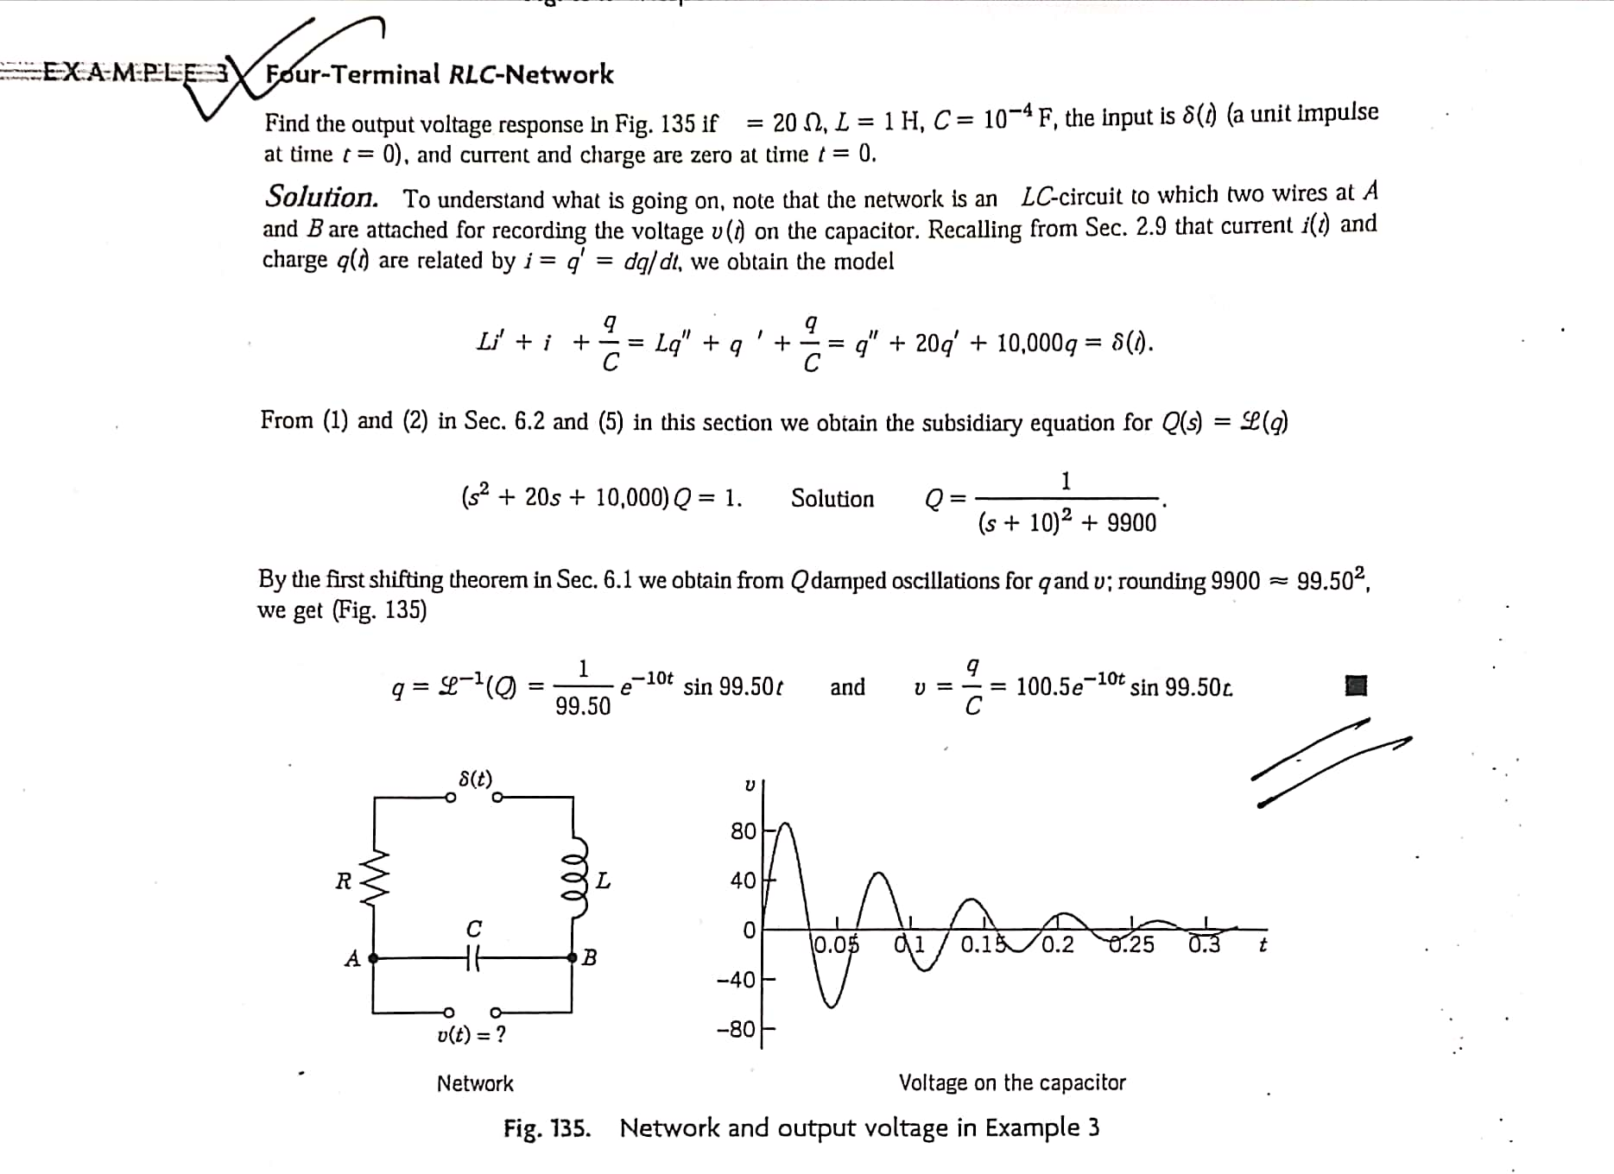

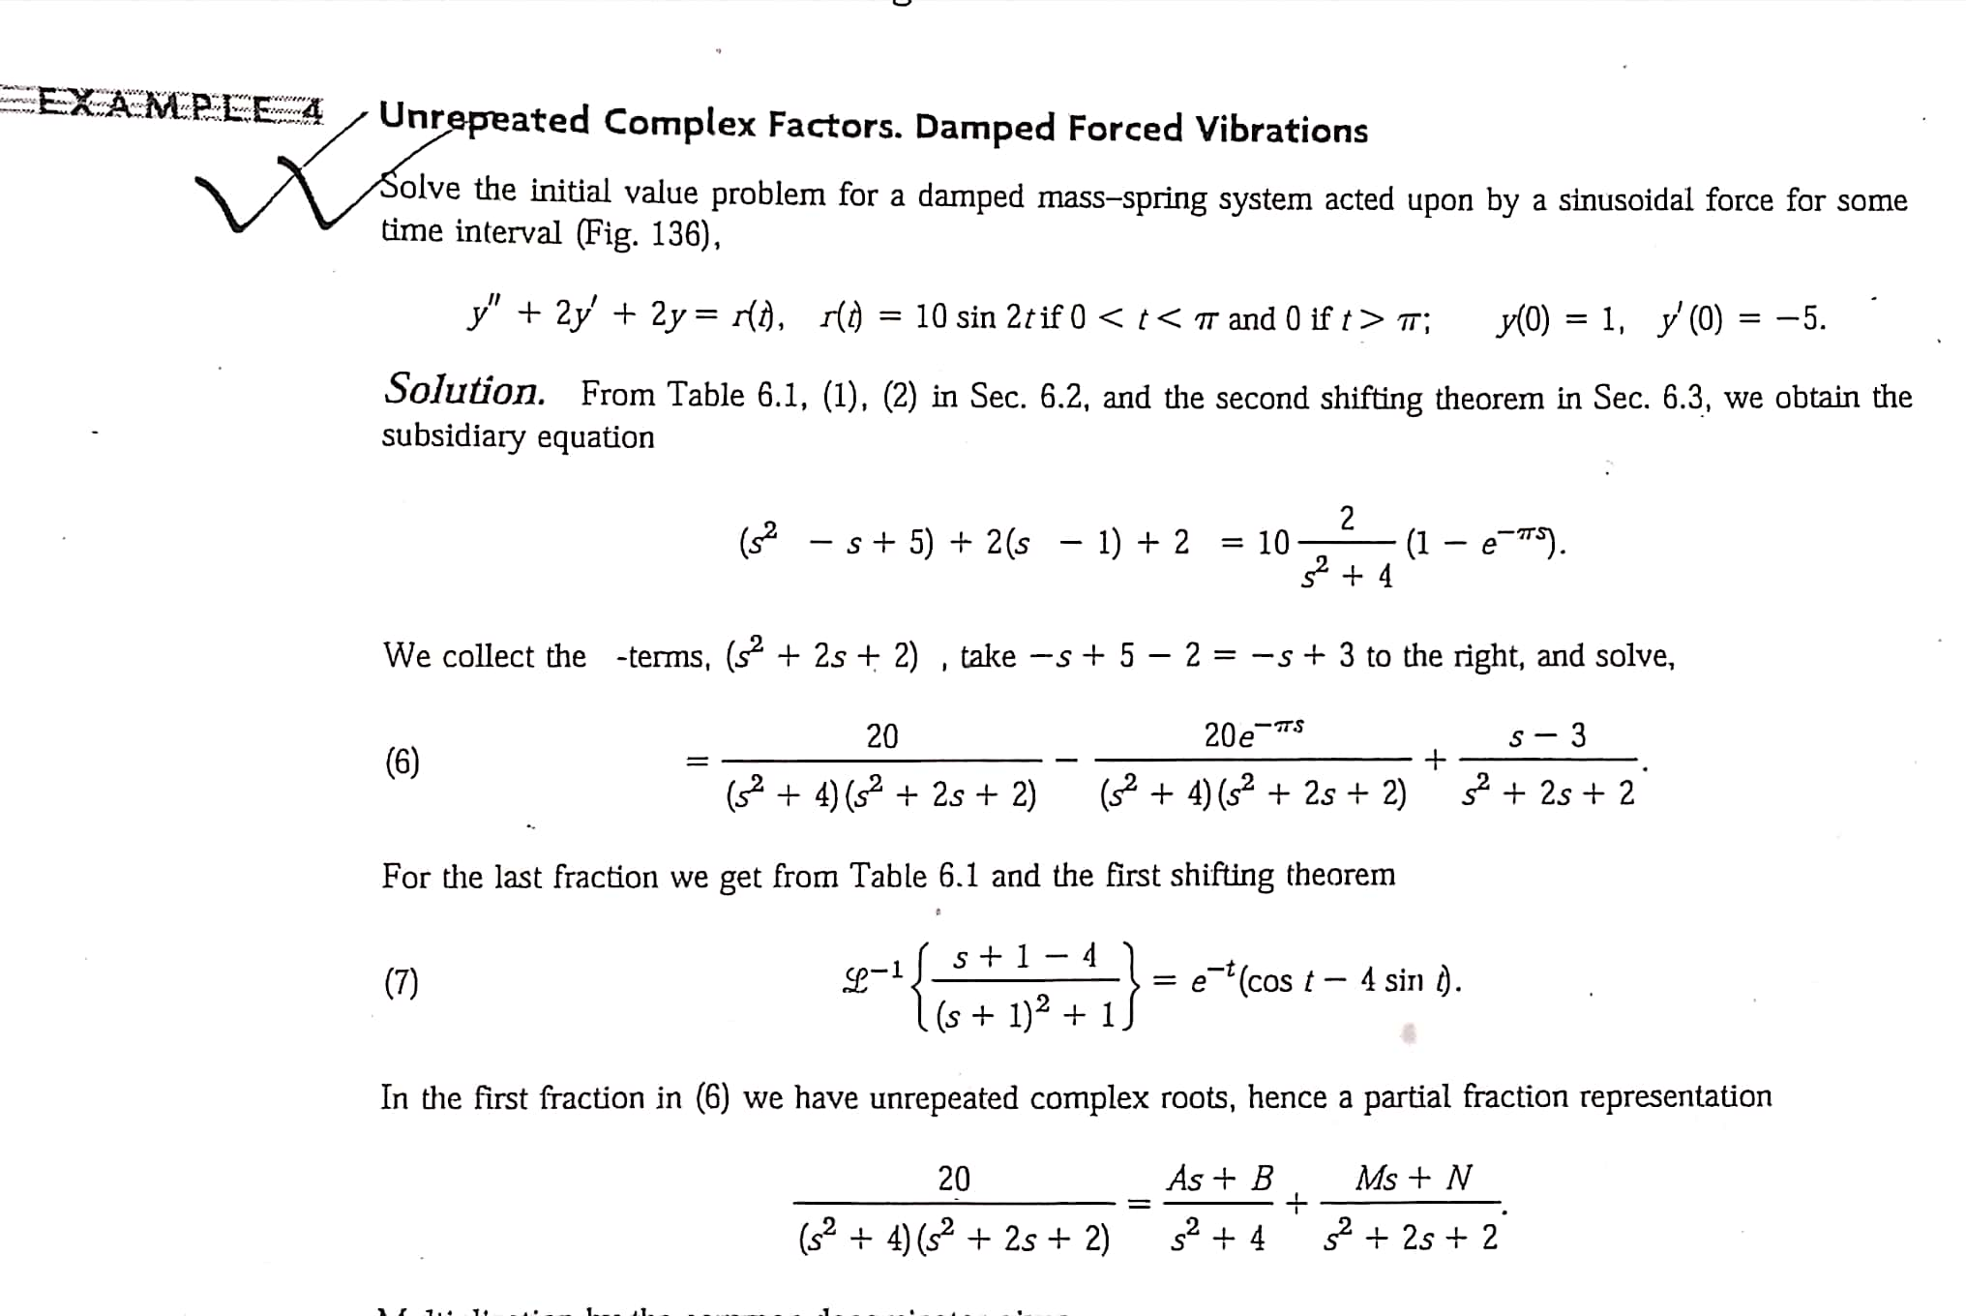

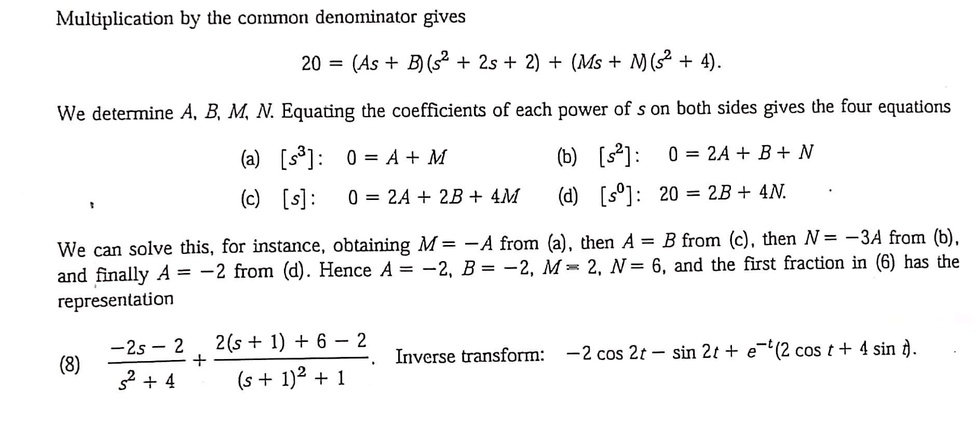

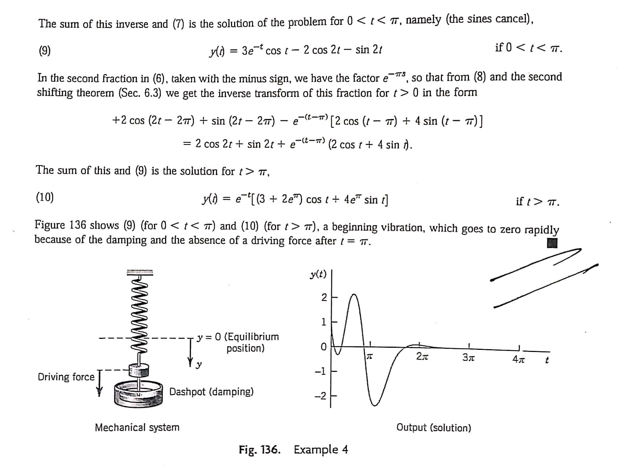

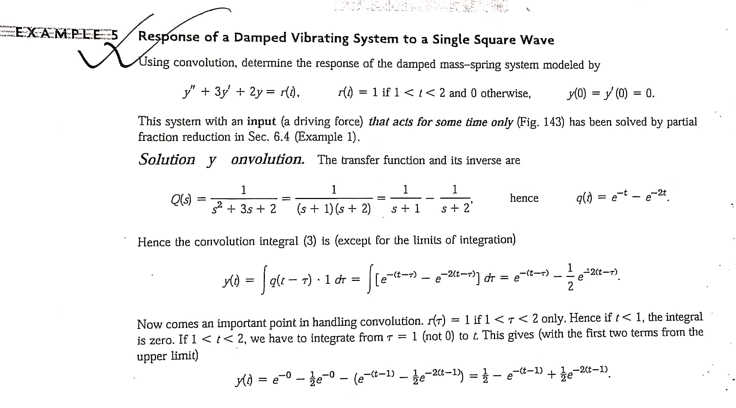

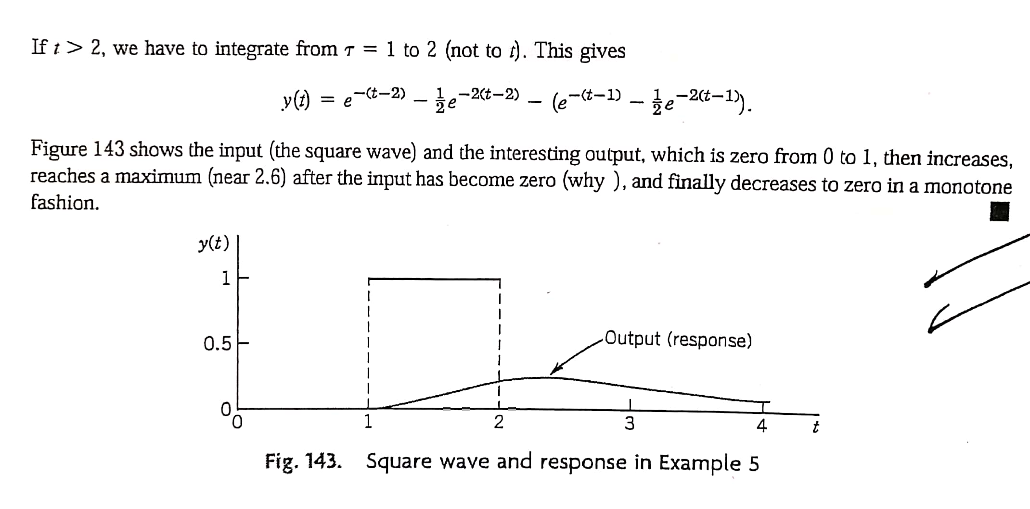

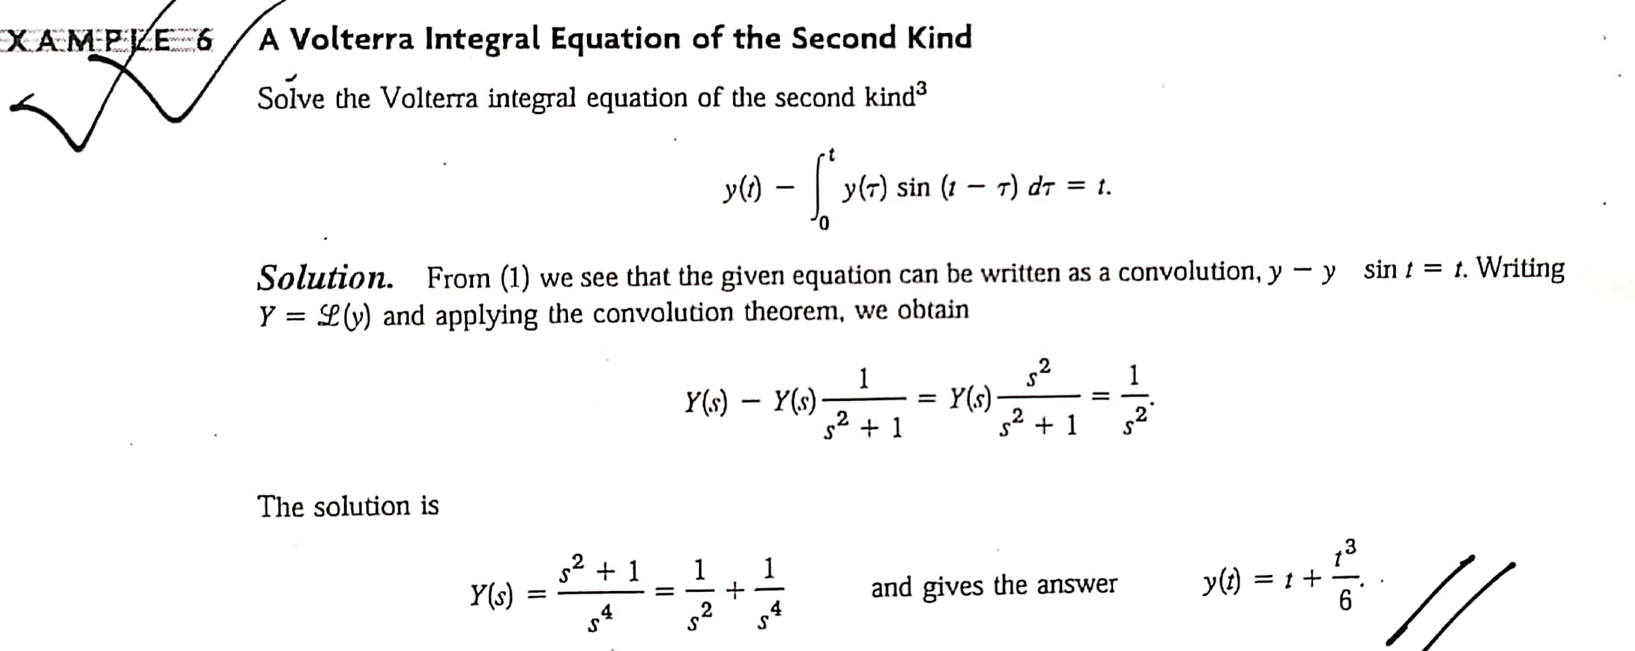

Find the solution of following DE’s using Laplace Transformation:
Ref: Differential Equations by Paul Blanchard, Robert L. Devaney & Glen R. Hall , Fourth Edition -Page-577(15-24),Page-600(27-34), Page 608(2-6).

